*Rowan Moody and Caroline Williams*

*WCS - Advanced Remote Sensing Report*

*June 4th, 2021*

**Title**

An Analysis of Baseline Trends for Environmental Monitoring in the Ruaha-Katavi landscape

**Research Question and Hypothesis**

What are the environmental trends in and around the Ruaha and Katavi National Parks in Tanzania?

**Research Goals**

* Monitor trends in fire occurrences, greenness, human population density, precipitation, and surface water in the Ruaha and Katavi study area between the years 2000 and 2020.
* Based on modeled trends, provide information on potential impacts of environmental change on wildlife habitat and migration corridors within the study area.
* Rate Ruaha, Katavi, and non-national park areas within the study area based on recorded trends.

**Study Area**

The study area of this research is constrained to the area around and between the National Parks of Ruaha and Katavi in Tanzania (Figure 1). Located in the western section of Tanzania, this area contains approximately 119,214 km2 of mixed land-cover types and land-uses. The Ruaha National Park, established in 1964, is located in the eastern portion of the research study area and covers approximately 20,226 km2. Opposite Ruaha in the western portion of the research study area, the Katavi National Park covers approximately 4,471 km2 and was established in 1974.

The primary dynamics and focus of this research are represented through a conceptual framework, denoting both the variables to be examined in the trends analysis, and ancillary data to be used in the context of the study area to understand the resulting trends (Figure 2 and table 1). This area is representative of a complex landscape, with a mix of different land protections and uses, including national parks, game refuges, and local communities (Mulder *et al*. 2007). We expect any trends in surface water to play strongly into landscape impacts. Studies such as Caro *et al.* (2013) and Epaphras *et al*. (2008) have documented the importance of water availability for the flora and fauna of the Ruaha-Katavi landscape. Additionally, the allocation of water resources to domestic and agricultural practices is impacting the availability of surface water, thereby making this trends analysis crucial for nearby species (Stommel, Hofer, & East, 2016). Examining environmental trends, such as surface water, in protected areas like Ruaha and Katavi, is essential as many conservationists express protected areas as the best method for species conservation (Stoner et al., 2007).

**Data Description**

See Table 1.

**Methods**The main components of the trends analysis included preprocessing data, both raster and vector, conducting our trends analysis, and providing statistical and descriptive results for each environmental variable (Figure 3). The first component featured processing the data by converting from vector to raster, clipping each variable to the Ruaha and Katavi study area boundary shapefile, provided by WCS, projecting to a consistent coordinate system such as UTM 36S, and preparing the data for TerrSet by importing them in .rst file format and creating a time series file (.tsf file extension) for Earth Trends Modeler (ETM). The second element to our analysis involved analyzing trends in TerrSet using ETM as well as utilizing simple raster calculations. This included examining data from 2000 to 2020. Some data were examined monthly, like precipitation and EVI, while others annually, like surface water, due to current availability in data. In addition to the spatial trends analysis, temporal trends were examined for each variable. This included observing the mean value over time as well as the frequency and pixel count per square kilometer. The third step consisted of producing statistical results and maps for each variable. This was accomplished in ETM’s Series Trend Analysis, using the Mann-Kendall statistic for monotonic trends and Theil-Sen Median trends analysis. The statistical significance of these results were identified using the Mann-Kendall significance test and Contextual Mann-Kendall test for significance in ETM. Following this three-step analysis, visual results were produced and condensed into informative report cards of each zone within the study area. Both open-source and commercial software and packages were used for this analysis, including R, ArcGIS Pro, Google Earth Engine, and TerrSet 2020.

**Results**

*Population*

Population has increased across the entire Ruaha and Katavi landscape between 2000 and 2020. Figure 4 shows a progression of population growth within the study area, showing the development and expansion of populated areas. Much of the increases are around previously established settlements, especially in this central portion of the study area where we’ve seen a lot of agricultural land use. Katavi has been subject to a 90% increase in population between 2000 and 2020 compared to the respective increases of 68% and 81% in the Ruaha and Mixed Use areas (see table 2). The entire study area contains over one million people as of 2020. The mixed use area shows a high and steadily increasing population density (Figure 5). Katavi shows a more dynamic trend, with a dip in density in 2016, but still showing a steady increase. Ruaha also shows an increasing population density, but from a much lower value and a much lower rate.

*Vegetation*

The resulting EVI trends in terms of monotonicity demonstrate areas of consistent increase and decrease across the landscape (Figure 6). Much of the region is experiencing an increase in EVI, most notably in Katavi and just east of the National Park. Additionally, Ruaha is also showing major areas of increase, however unlike Katavi, Ruaha is showing a clear decrease in the southern region and bordering areas. This trend in southern Ruaha is likely due to increasing population in the region. In the Mixed Use region, there is a distinct decrease in EVI that occurs in the center of the study area. Overlaid in blue, is the agriculture ancillary dataset from 2019. It is therefore likely that this decreasing EVI in the Mixed Use area can be attributed to agricultural land use. Based on the livelihoods data, this agriculture region includes tobacco and maize production. There are also areas of no significant EVI change in white. While there is definite spatial variability in greeness, temporally EVI shows an overall increasing trend across Ruaha, Katavi, and the Mixed Use region (Figure 7). Katavi has experienced the greatest change in EVI with a 17.27% increase based on 2001 and 2020 mean values. While Katavi is experiencing the greatest change, Ruaha (16.59%) and Mixed Use (15.40%) is not far behind in terms of magnitude.

*Fire*

We see that there is great annual variability in fire density between 2000 and 2020 across all three areas, with Katavi showing the highest density and Ruaha the least (Figure 8). The western portion of the study area in and around Katavi has a much higher frequency and density of fire occurrences, as we can see in both Figures 8and 9, having more than twice the fires per square kilometer than in the Ruaha and Mixed use areas. Overall, the number and density of fires in the Ruaha and Katavi areas were increasing by approximately 15% between 2002 and 2020 based on a 5-year average. Over the same time period, the Mixed Use area showed an 11% decrease in fire occurrence and density, which we believe is reflective of increased human development and use in the landscape. Fire data from 2001 were excluded from the statistical portion of this analysis, as the dataset does not reflect the full year’s worth of fires and would have affected the trend as an outlier.

*Surface Water*

Percentage of surface water change shows variable trends across the Ruaha and Katavi landscape (Figure 10). Along the perimeter of Lake Rukwa, there is an undoubtedly large decrease in surface water, as the lake recedes in the north and surrounding areas. Meanwhile in northern Katavi and southern Ruaha, there is a clear increase in surface water. Some of this increase in surface water can be attributed to the presence of rice paddy agriculture. This relation was verified in Ruaha near the southern border of the National Park using satellite imagery. Some areas are showing mixed trends, particularly in northern Ruaha along the nearby river with pixels alongside one another showing both increase and decrease. Based on these spatial trends, Mixed Use shows the highest change although less than 1% difference at 0.78% decrease. Meanwhile, Ruaha (0.21%) and Katavi (0.15%) are showing an increasing trend. Seasonal and permanent surface water trends were also examined. Seasonal trends in Ruaha show much temporal variability, although peaking in recent years (Figure 11). Katavi is similarly showing higher amounts of seasonal surface water recently. Although Ruaha and Katavi are showing seasonal surface water increase, seasonal Mixed Use water is stable, while permanent Mixed Use water is demonstrating a steady decrease over the last two decades.

*Precipitation*

Spatial precipitation trends show no significant change across much of the study area (Figure 12). Most significant precipitation trends are concentrated above Lake Rukwa, just slightly west of the Lake, and most notably in southern Ruaha. This trend in southern Ruaha is the strongest area of precipitation change. Temporarily, across all three sites there is annual variability over the 18 year period (Figure 13). Based on 2000 and 2018 values, Ruaha showed the greatest increase at 20.97%. While not as strong of a change, Mixed Use (15.86%) areas and Katavi (8.45%) showed a clear increase in precipitation.

This area is also characterized by a strong dry and wet season with the dry season showing little to no precipitation and the wet season experiencing up to ~ 274 mm of precipitation (Table 3). Mean monthly precipitation from December to March is relatively consistent in its spatial distribution (Figure 14). Particularly the western portion of the study area is slightly more wet than its eastern counterpart. While the distribution is similar, the magnitude across these means differs. Specifically, February and March show lower means than December. In contrast, the latest wet season shows quite variable magnitudes and distributions. December and February are considerably dry in the central and northern regions compared to their means. Even if the maximum value is higher than the mean maximum of its month, the spatial distribution shows a much greater gradient in precipitation. January and March are showing higher precipitation than their means for 2018 even between the irregular December and February months. Although we saw no significant changes in seasonality and the timing of seasons, it is important to examine the individual wet seasons closely for variability especially in contrast to the monthly means.

**Conclusion**

The Ruaha and Katavi landscape is experiencing a variety of trends and typically co-occurring in three major regions (Figure 15). Southern Katavi and northern Lake Rukwa is an area experiencing dynamic change. Particularly, this location is showing an increase in precipitation, decrease in surface water with the receding lake, and notable changes in EVI. Another area of increasing population is found along the center region in the Mixed Use area. Coinciding with this trend, there is a distinct decrease in both fire and EVI, likely due to agriculture. The third major area of dynamic change is southern Ruaha and its surrounding area. This region is experiencing a major increase in population, decrease in fire frequency and EVI, and strong increase in precipitation. These three areas of dynamic change are the most notable in terms of locations experiencing more than one major trend among these variables.

With the results of this study, experts out in the field can utilize these results to enhance the understanding of spatial and temporal enviro-climatic, landscape, and human activity and interaction trends in the Ruaha and Katavi National parks and surrounding Mixed Use areas.

**Acknowledgements**

Many thanks to David Wilke and Danielle LaBruna of the Wildlife Conservation Society (WCS) for their collaboration on this project. Additional thanks to John Rogan and Nicholas Geron of Clark University for their support and mentorship throughout this semester.

**Figures and Tables**

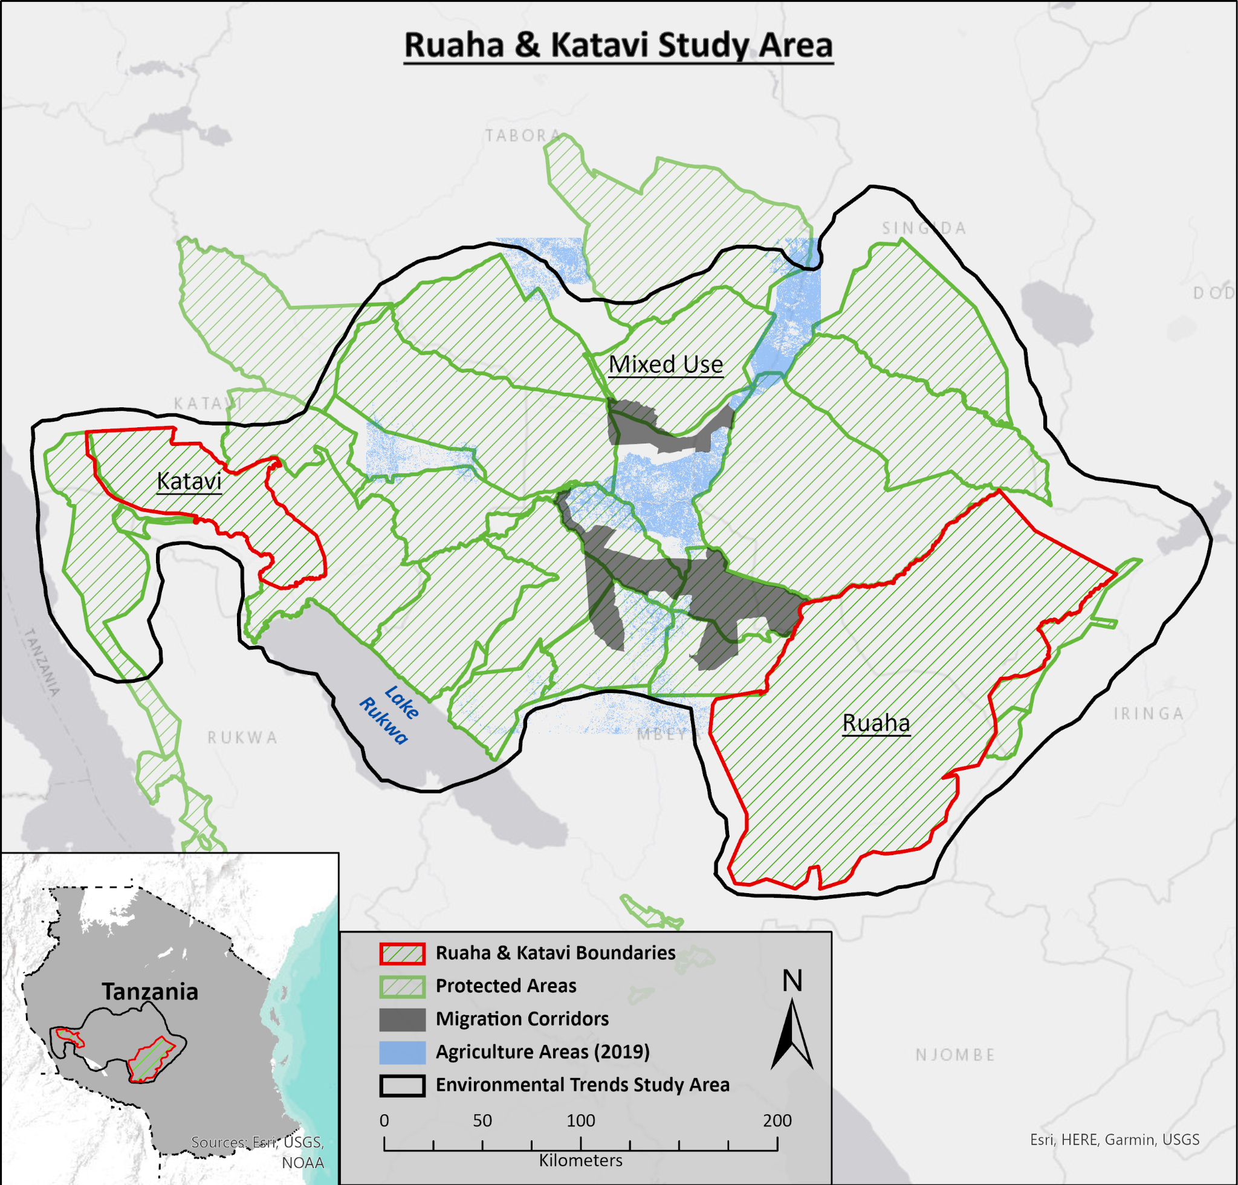  
Figure 1: Study area map of the area around and between Ruaha and Katavi National Parks

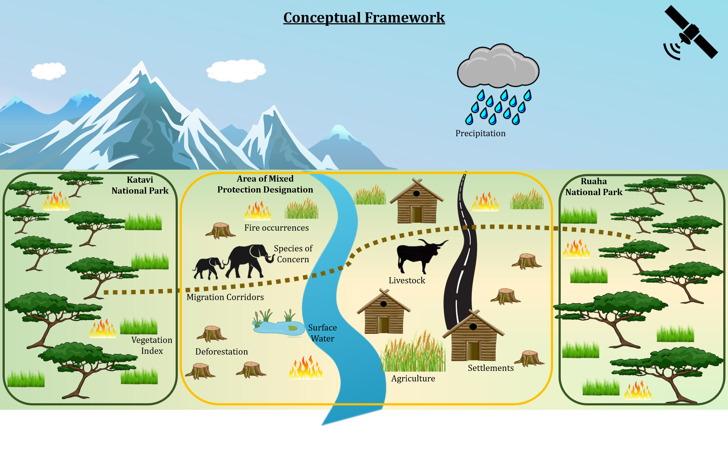  
Figure 2: Conceptual framework of the variables and dynamics within the study area landscape.

Table 1: Data table of input and ancillary variables used in this study.

| ***Variable*** | ***Type*** | ***Spatial Resolution*** | ***Temporal Resolution*** | ***Source*** |
| --- | --- | --- | --- | --- |
| Agriculture | Raster | 30 m | 2009, 2014, 2019 | Landsat 8 - <https://www.usgs.gov/core-science-systems/nli/landsat/landsat-8?qt-science_support_page_related_con=0#qt-science_support_page_related_con> |
| Fire | Shapefile/Raster | Point, aggregated to 10 km | 2001-2020 | MODIS - <https://firms.modaps.eosdis.nasa.gov/active_fire/#firms-shapefile> |
| Population | Raster | 1 km | 2000 - 2020 | WorldPop -  <https://www.worldpop.org/geodata/listing?id=75> |
| Precipitation | Raster | 2.5 minutes | 2000-2018 | WorldClim -  <https://www.worldclim.org/data/monthlywth.html> |
| Surface Water | Raster | 10° | 1984 - 2019 | Global Surface Water Explorer -  <https://global-surface-water.appspot.com/> |
| Vegetation | Raster | 250 m | 2000 - 2021 | MODIS - <https://modis.gsfc.nasa.gov/data/dataprod/mod13.php> |

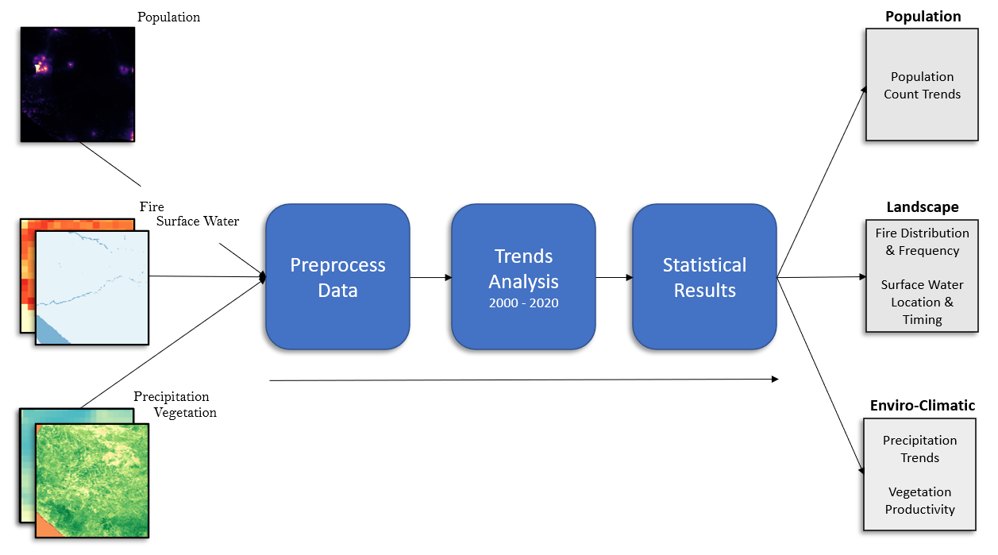Figure 3: Flowchart of proposed methodology of research

  
Figure 4: Gif of population growth in the study area

Table 2: Population change between 2000 and 2020

| **Population Change** | *Katavi* | *Ruaha* | *Mixed Use* | *Study Area* |
| --- | --- | --- | --- | --- |
| *2000* | 19,380 | 55,049 | 498,665 | 573,093 |
| *2020* | 36,838 | 92,669 | 902,437 | 1,031,944 |
| *Percent Change* | +90.08% | +68.34% | +80.97% | +80.07% |

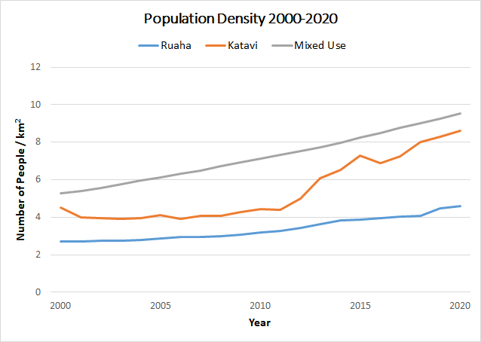  
Figure 5: Population density within the Ruaha, Katavi, and Mixed Use areas.

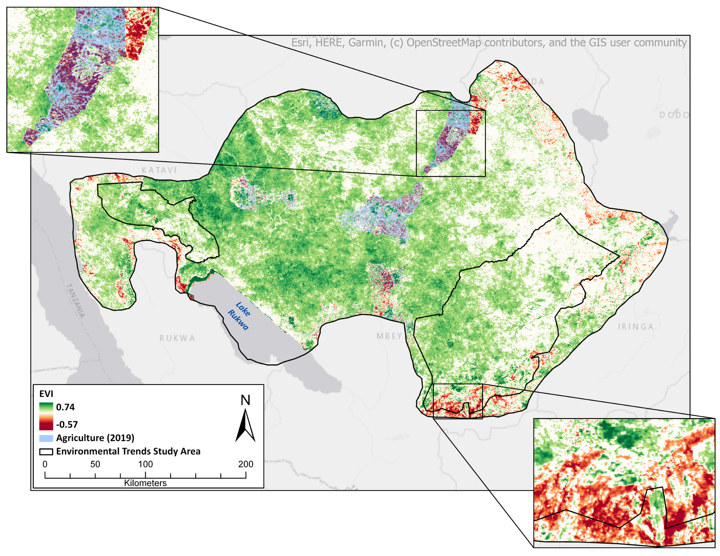

Figure 6. Monotonic trends in Enhanced Vegetation Index (EVI) depicting areas of statistically consistent increase (green) or decrease (red).

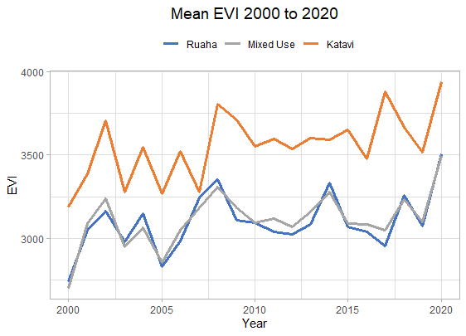  
Figure 7. Temporal EVI trends for Ruaha and Katavi National Parks and Mixed Use areas.

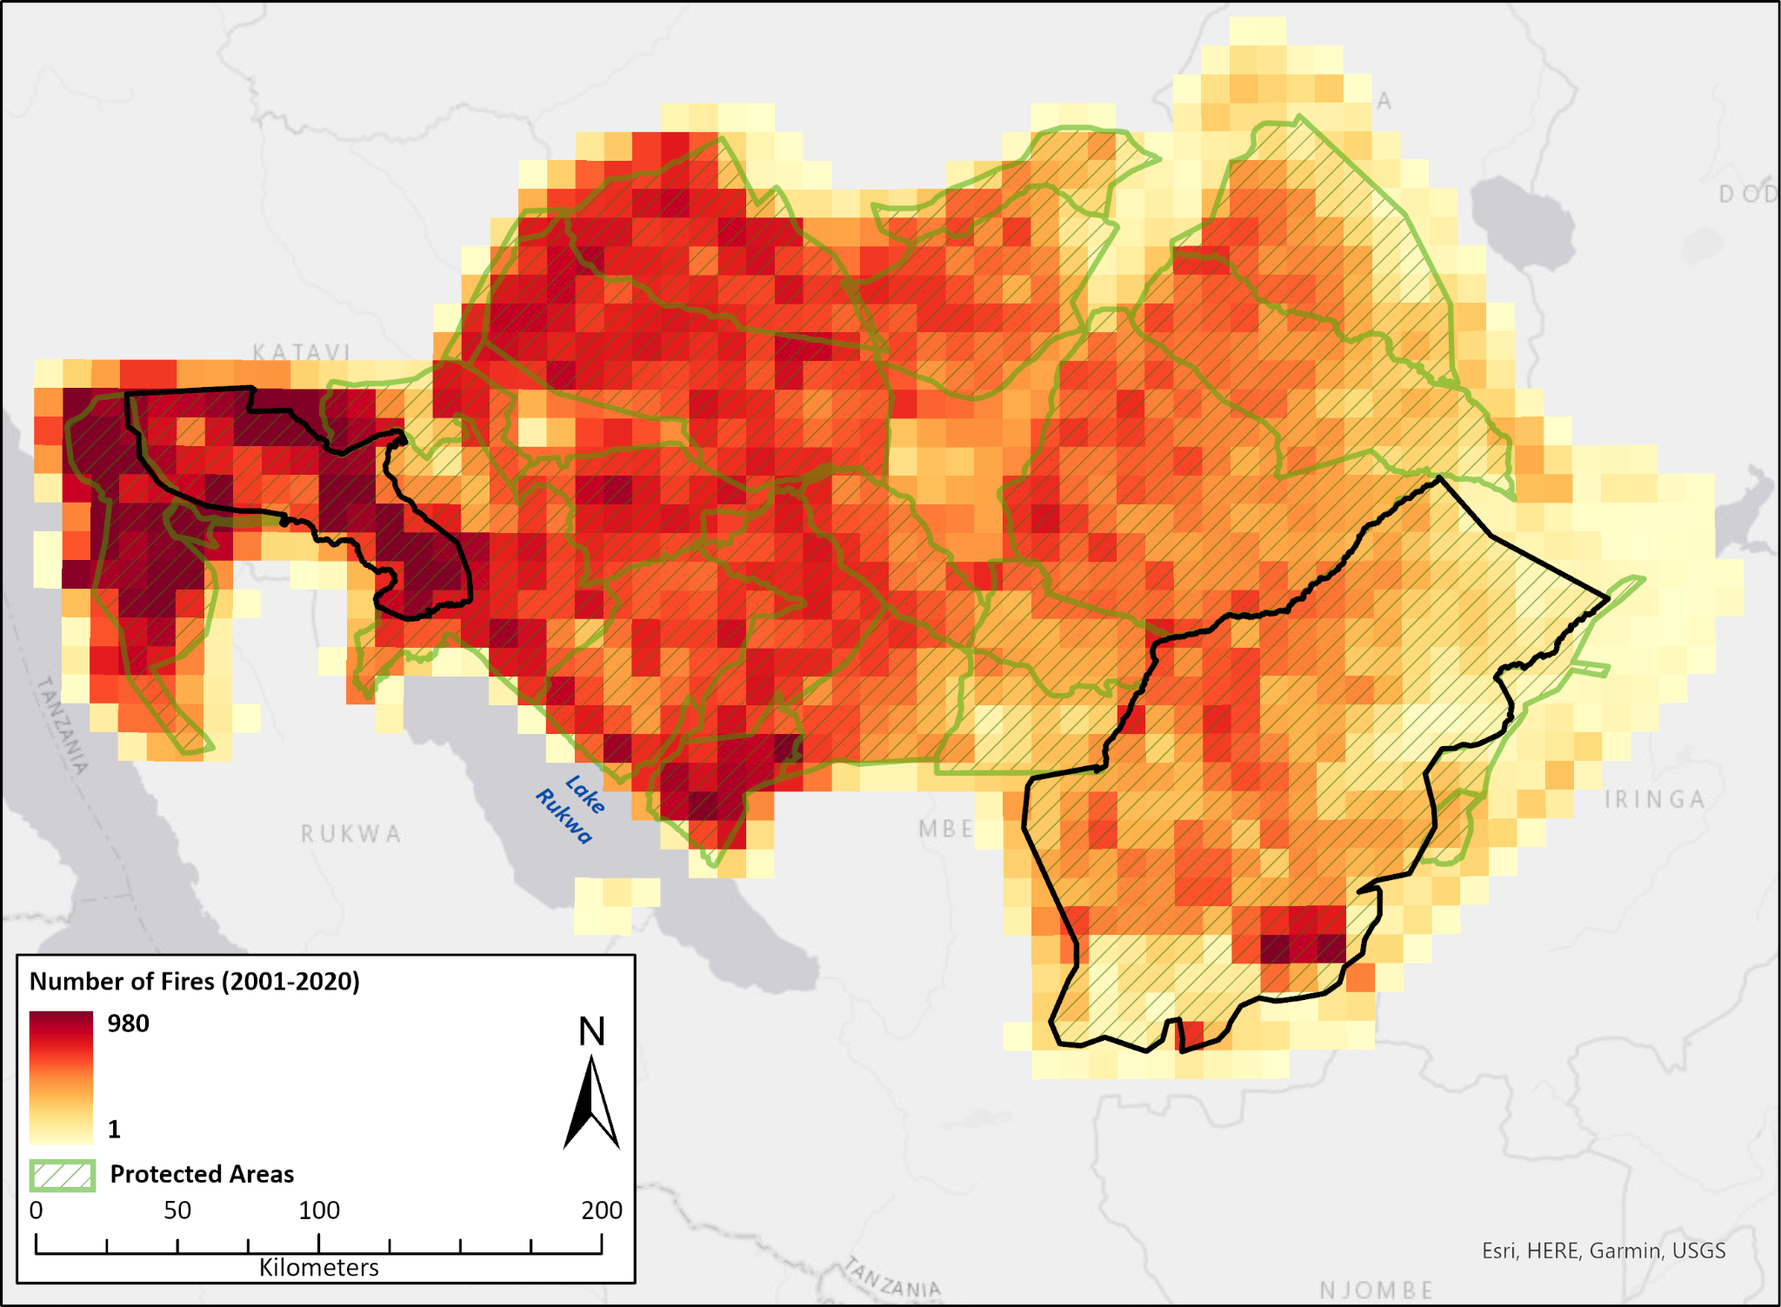Figure 8: Fire count within study area aggregated to 10 km cells

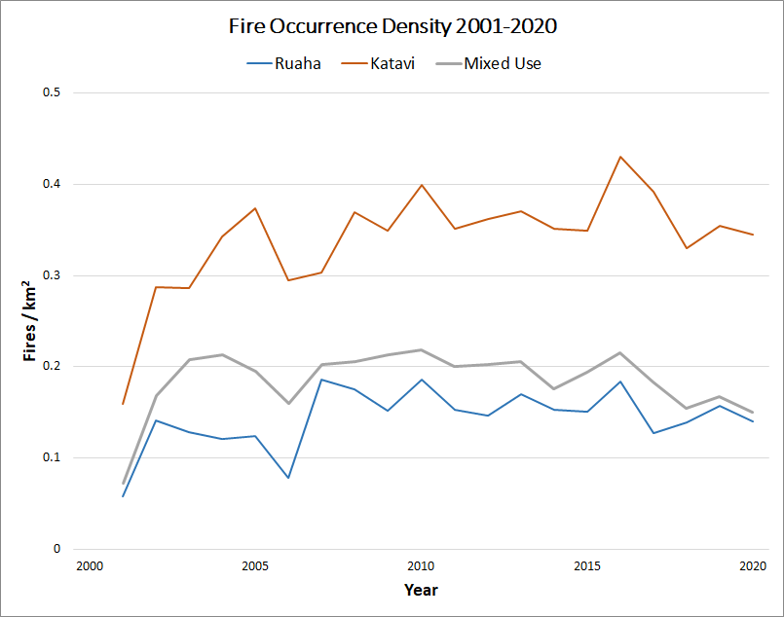  
Figure 9: Fire density within the Ruaha, Katavi, and Mixed Use areas.

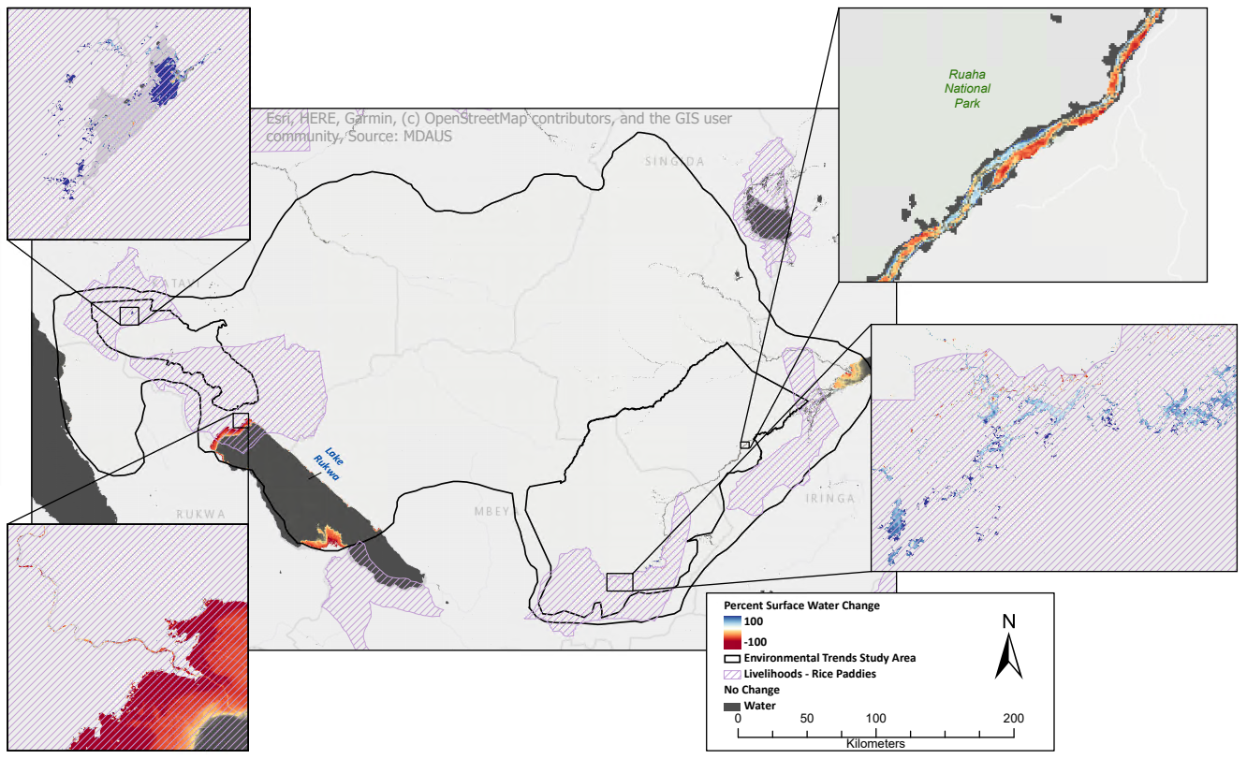  
Figure 10. Percentage of surface water change is depicted as increasing (blue) or decreasing (red). Rice Paddy agriculture is highlighted in pink hatch marks with areas of no surface water change in dark grey.

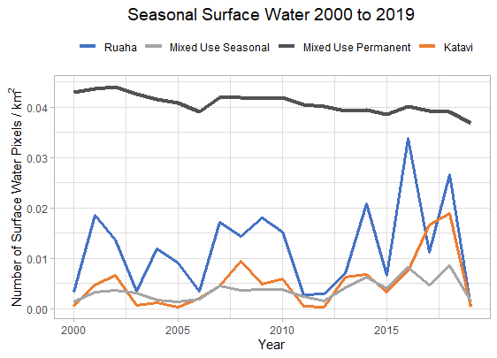

Figure 11. Trends in surface water are shown by study sites, Katavi, Ruaha, and Mixed Use, specifically the number of surface water pixels per square kilometer.

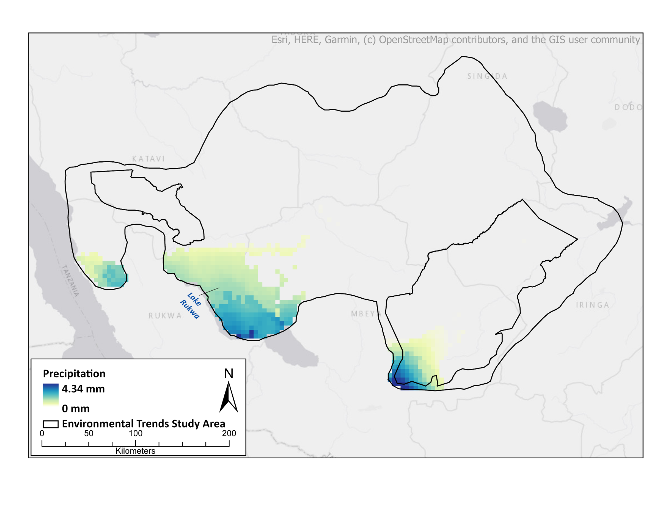

Figure 12. Significant precipitation trends from 2000 to 2018 are presented showing a maximum of 4.34 mm increase.

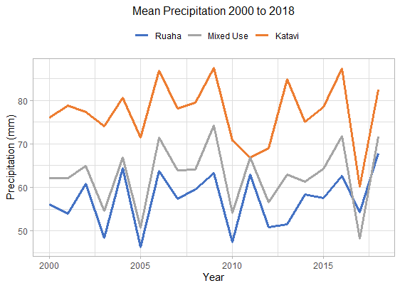  
Figure 13. Trends in mean precipitation are presented with a slight increase across all three sites over the nearly two decade period.

Table 3. Mean monthly maximum precipitation and the most recent wet season.

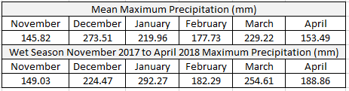

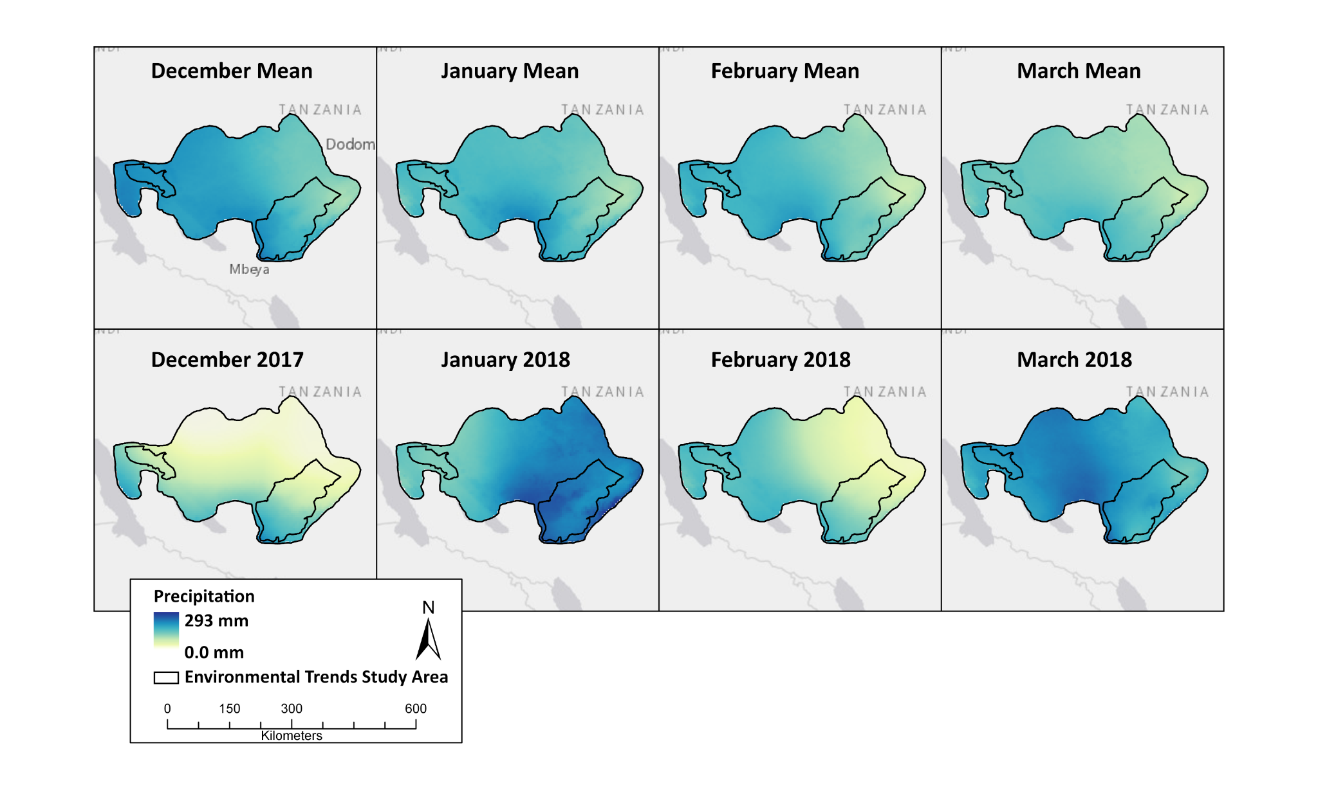

Figure 14. The mean precipitation by month for the wet season is presented (first row). In addition, the latest example of the region’s wet season is shown with January and March as the wettest months in the season of 2017 to 2018 (second row).

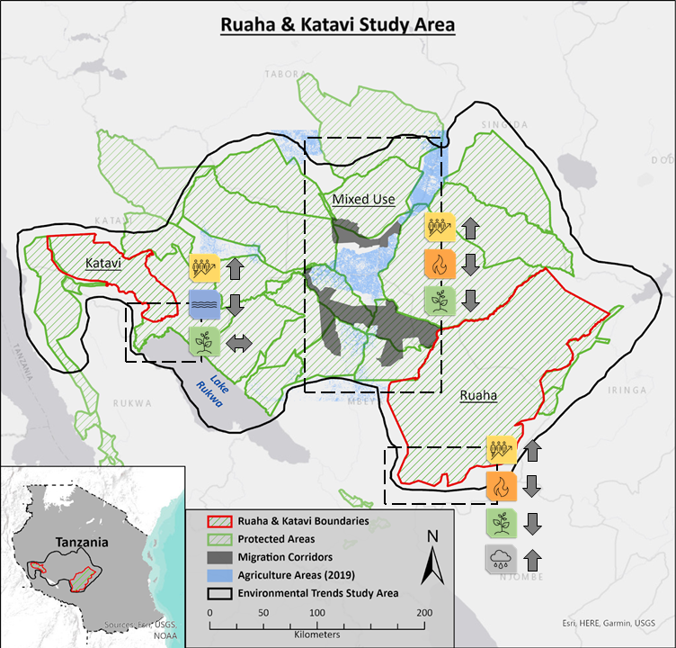  
Figure 15: Ruaha and Katavi study area overlaid with three areas of dynamic trends identified in population, vegetation, surface water, fire occurrences, and precipitation.

**References**

Epaphras, A. M., Gereta, E., Lejora, I. A., Meing’ataki, G. O., Ng’umbi, G., Kiwango, Y., ... & Mtahiko, M. G. G. (2008). Wildlife water utilization and importance of artificial waterholes during dry season at Ruaha National Park, Tanzania. *Wetlands ecology and management*, *16*(3), 183-188. <https://link.springer.com/content/pdf/10.1007/s11273-007-9065-3.pdf>

Mulder, M. B., Caro, T. I. M., & Msago, O. A. (2007). The role of research in evaluating conservation strategies in Tanzania: the case of the Katavi‐Rukwa ecosystem. *Conservation Biology*, *21*(3), 647-658. <https://conbio.onlinelibrary.wiley.com/doi/abs/10.1111/j.1523-1739.2007.00703.x>

Caro, T., Martin, A., Elisa, M., Gara, J., Kadomo, D., Mushi, D., & Timbuka, C. (2013). Integrating research with management: the case of Katavi National Park, Tanzania. *African Zoology*, *48*(1), 1-12. <https://goddard40.clarku.edu:2083/illiad/illiad.dll?Action=10&Form=75&Value=100862>

Stommel, C., Hofer, H., & East, M. L. (2016). The Effect of Reduced Water Availability in the

Great Ruaha River on the Vulnerable Common Hippopotamus in the Ruaha National

Park, Tanzania. *PLOS ONE, 11*(6), e0157145.

<https://journals.plos.org/plosone/article?id=10.1371/journal.pone.0157145>

Stoner, C., Caro, T. I. M., Mduma, S., Mlingwa, C., Sabuni, G., & Borner, M. (2007).

Assessment of Effectiveness of Protection Strategies in Tanzania Based on a Decade of Survey Data for Large Herbivores. *Conservation Biology, 21*(3), 635-646. <https://conbio.onlinelibrary.wiley.com/doi/full/10.1111/j.1523-1739.2007.00705.x>